How Do We Spend?
Name: _______________________
- This pie chart represents how I think adults use their money for spending, saving, and giving/donating:
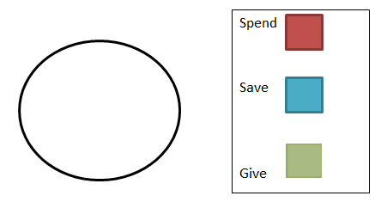
- This pie chart represents how I think my friends use their money for spending, saving, and giving/donating:
- This pie chart represents how I use my money for spending, saving, and giving/donating:

Homework Directions: Review problems 1-3 with your parents and explain your thinking. Then, together, complete the below graph and questions.
- This pie chart represents how my parents and I think I should use my money for spending, saving, and giving/donating:
- What percentage or fraction did you decide you should spend? Is this different from your response in question 3? Why?
____________________________________________________________________________________________________________________________________________________________________________________________________________________________________________________
- What percentage or fraction did you decide you should save? Is this different from your response in question 3? Why?
____________________________________________________________________________________________________________________________________________________________________________________________________________________________________________________
- What percentage or fraction did you decide you should give/donate? Is this different from your response in question 3? Why?
____________________________________________________________________________________________________________________________________________________________________________________________________________________________________________________

